**Experiment No. 4**

**Experiment Title: Support Vector Machine(SVM)**

|  |
| --- |
| Student Name: YANA SRIVASTAVA UID: 20BCS2279  Branch: CSE Section/Group: 20BCS-WM-906/B  Semester: 5th Date of Performance: 14/10/22  Subject Name: Machine Learning Lab Subject Code: 21CSP-317 |

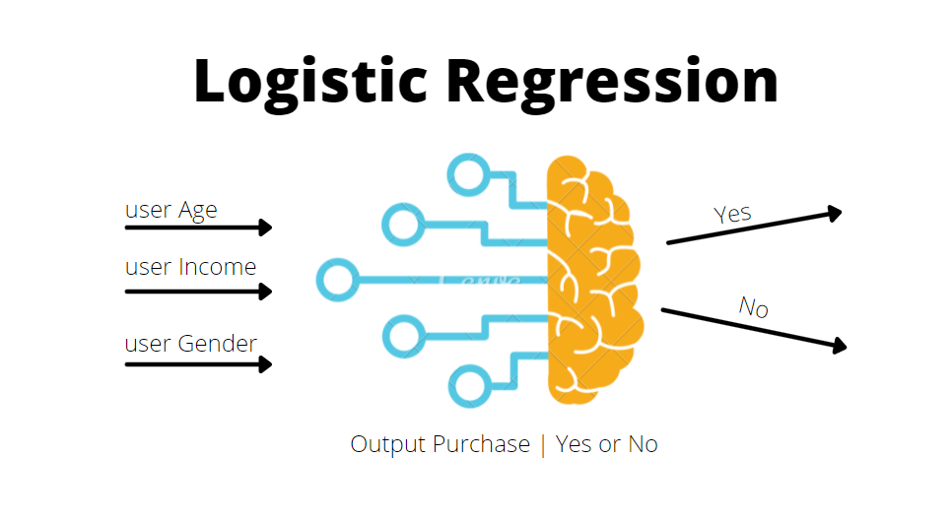

1. **Aim/Overview of the practical:**

Implement Support Vector Machine on any data set and analyze the accuracy with Logistic regression**.**

1. **Steps of Experiment:**
   * Import all the required library.
   * Import the dataset which you want to implement.
   * Split data into x and y and perform some task.
   * Split data into training set and testing set.
   * Feature Scaling
   * Predict The test set result
   * Check the accuracy score by using different kernel
   * Plot the train data
   * Plot the test data
   * Predicting the test set result
   * Plot data points
   * Create the hyperplane
   * Plot the hyperplane
2. **Source Code/Result/Output:**

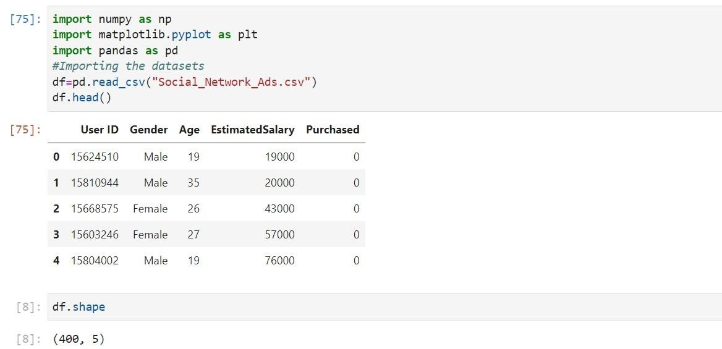

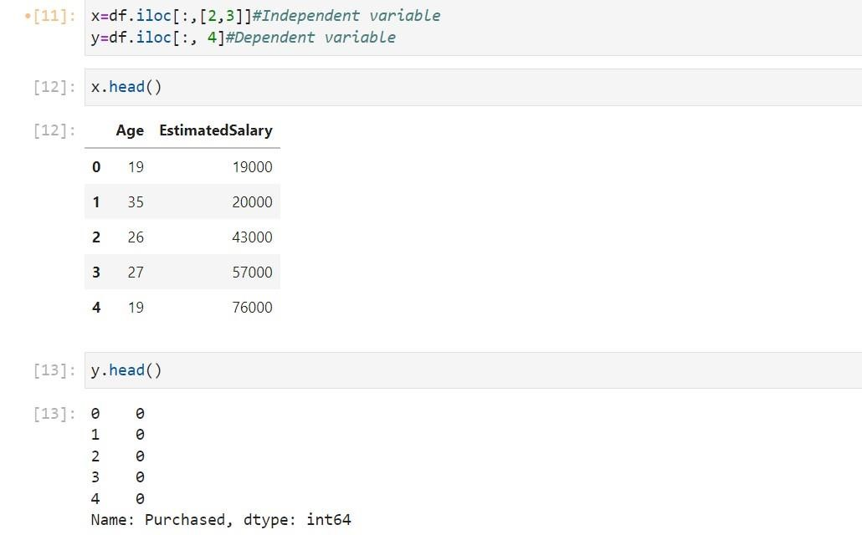

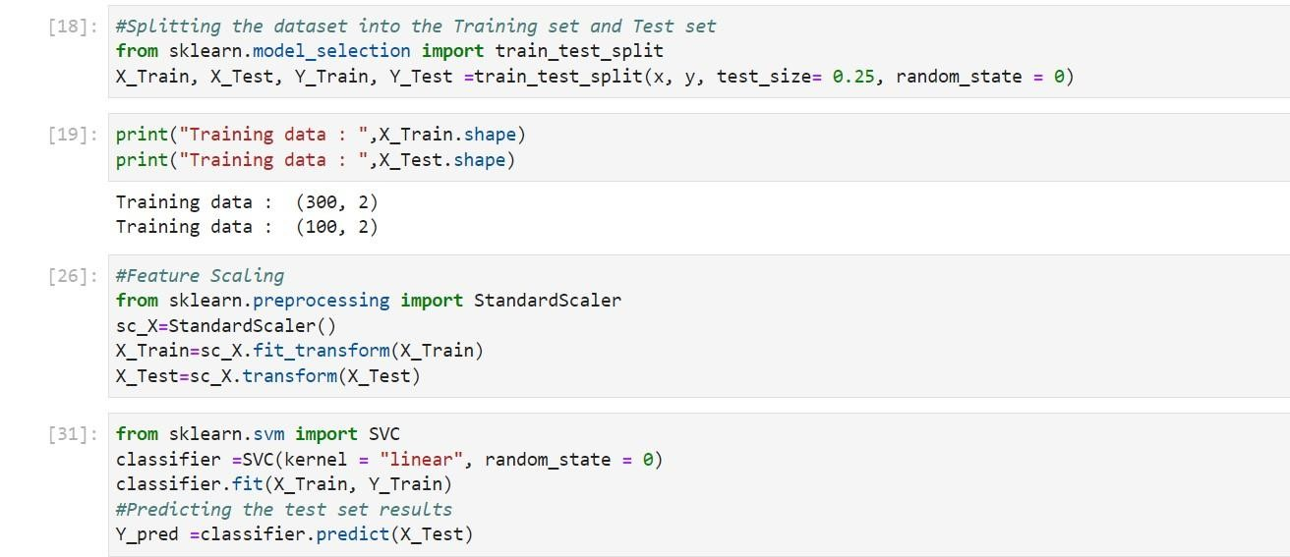

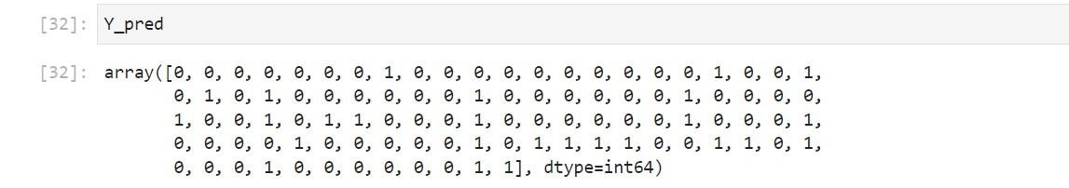

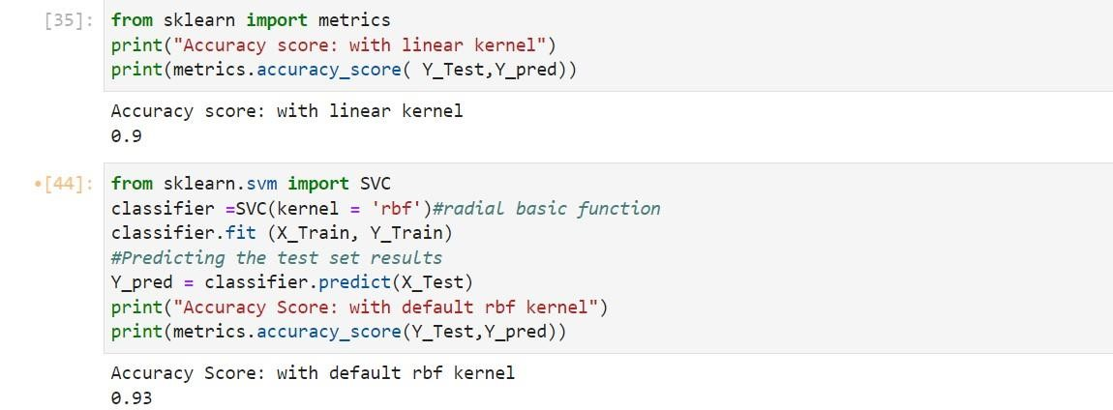

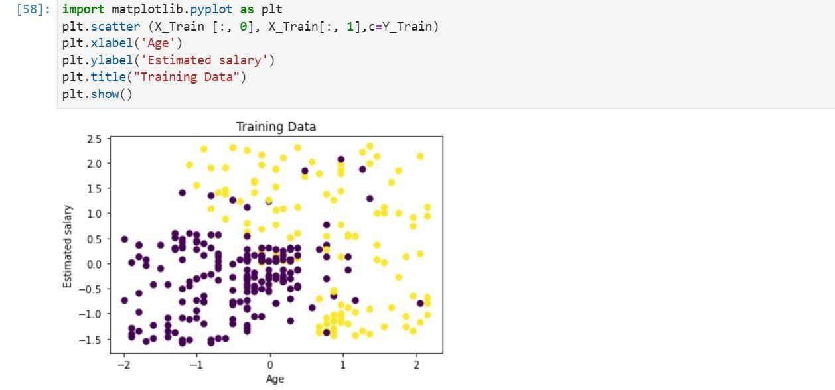

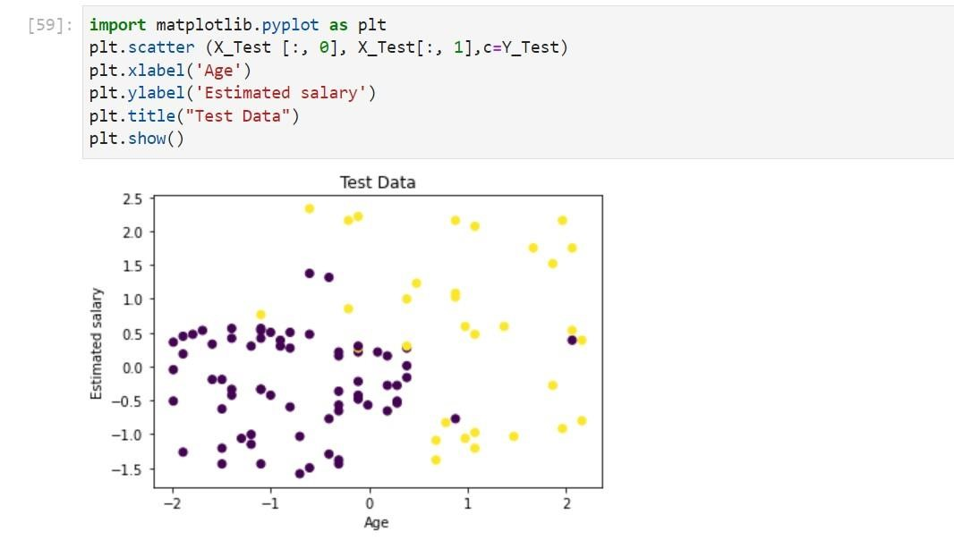

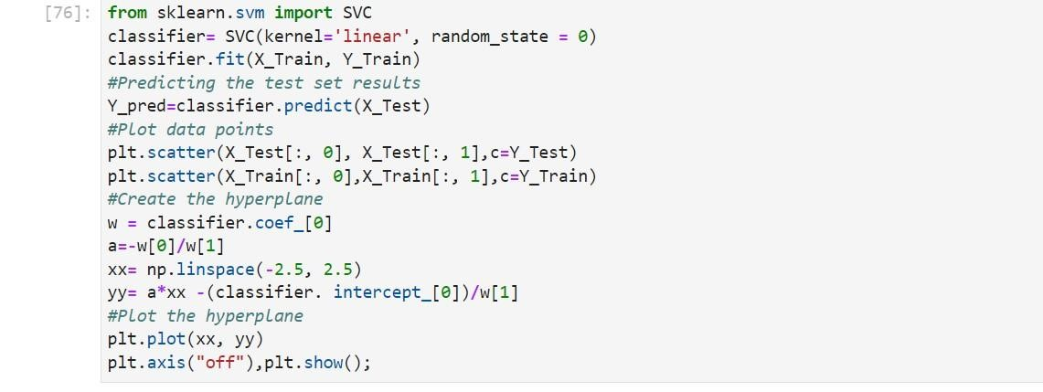

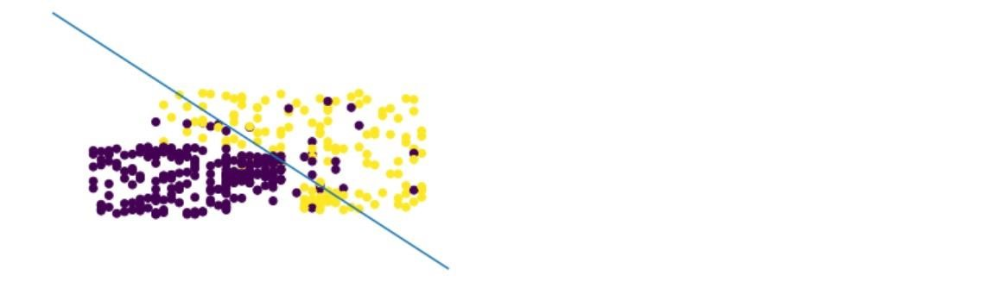

**Learning outcomes (What I have learnt):**

**1. Learnt to analyze the data.**

**2. Learnt to import various libraries.**

**3. Learnt to read csv files.**

**4. Learnt to implement Logistic Regression.**

**5. Learnt to train and test the data.**

**6. Learnt the concept of SVM (Support Vector Machine).**

**Evaluation Grid:**

|  |  |  |  |
| --- | --- | --- | --- |
| **Sr. No.** | **Parameters** | **Marks Obtained** | **Maximum Marks** |
| **1.** | **Student Performance  (Conduct of experiment) objectives/Outcomes.** |  | **12** |
| **2.** | **Viva Voce** |  | **10** |
| **3.** | **Submission of Work Sheet (Record)** |  | **8** |
|  | **Total** |  | **30** |